**WEEK 2: PL / SQL**

**Exercise 1: Control Structures**

**Scenario 1:** The bank wants to apply a discount to loan interest rates for customers above 60 years old.

* + **Question:** Write a PL/SQL block that loops through all customers, checks their age, and if they are above 60, apply a 1% discount to their current loan interest rates.

1. BEGIN
2. FOR c IN (SELECT * FROM Loans l JOIN Customers c ON l.CustomerID = c.CustomerID) LOOP
3. IF TRUNC(MONTHS_BETWEEN(SYSDATE, c.DOB)/12) > 60 THEN
4. UPDATE Loans SET InterestRate = InterestRate - 1 WHERE LoanID = c.LoanID;
5. END IF;
6. END LOOP;
7. END;
8. /

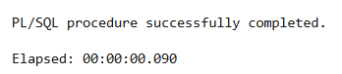

**Scenario 2:** A customer can be promoted to VIP status based on their balance.

* + **Question:** Write a PL/SQL block that iterates through all customers and sets a flag IsVIP to TRUE for those with a balance over $10,000.

1. ALTER TABLE Customers ADD IsVIP VARCHAR2(5);
2. BEGIN
3. FOR c IN (SELECT * FROM Customers) LOOP
4. IF c.Balance > 10000 THEN
5. UPDATE Customers SET IsVIP = 'TRUE', LastModified = SYSDATE WHERE CustomerID = c.CustomerID;
6. END IF;
7. END LOOP;
8. END;
9. /



**Scenario 3:** The bank wants to send reminders to customers whose loans are due within the next 30 days.

* + **Question:** Write a PL/SQL block that fetches all loans due in the next 30 days and prints a reminder message for each customer.

1. BEGIN
2. FOR l IN (SELECT * FROM Loans WHERE EndDate <= SYSDATE + 30) LOOP
3. DBMS_OUTPUT.PUT_LINE('Reminder: Loan ' || l.LoanID || ' for Customer ' || l.CustomerID || ' is due soon.');
4. END LOOP;
5. END;
6. /

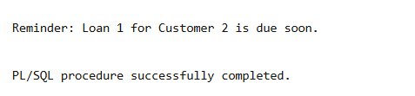

**Exercise 2: Error Handling**

**Scenario 1:** Handle exceptions during fund transfers between accounts.

* + **Question:** Write a stored procedure **SafeTransferFunds** that transfers funds between two accounts. Ensure that if any error occurs (e.g., insufficient funds), an appropriate error message is logged and the transaction is rolled back.

1. CREATE OR REPLACE PROCEDURE SafeTransferFunds(p_from NUMBER, p_to NUMBER, p_amt NUMBER) AS
2. BEGIN
3. UPDATE Accounts SET Balance = Balance - p_amt WHERE AccountID = p_from;
4. UPDATE Accounts SET Balance = Balance + p_amt WHERE AccountID = p_to;
5. COMMIT;
6. EXCEPTION
7. WHEN OTHERS THEN
8. ROLLBACK;
9. DBMS_OUTPUT.PUT_LINE('Error in fund transfer: ' || SQLERRM);
10. END;
11. /

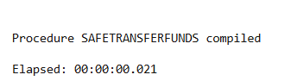

**Scenario 2:** Manage errors when updating employee salaries.

* + **Question:** Write a stored procedure **UpdateSalary** that increases the salary of an employee by a given percentage. If the employee ID does not exist, handle the exception and log an error message.

1. CREATE OR REPLACE PROCEDURE UpdateSalary(p_empid NUMBER, p_percent NUMBER) AS
2. BEGIN
3. UPDATE Employees SET Salary = Salary + (Salary * p_percent/100) WHERE EmployeeID = p_empid;
4. IF SQL%ROWCOUNT = 0 THEN
5. RAISE_APPLICATION_ERROR(-20001, 'Employee not found');
6. END IF;
7. EXCEPTION
8. WHEN OTHERS THEN
9. DBMS_OUTPUT.PUT_LINE('Error updating salary: ' || SQLERRM);
10. END;
11. /

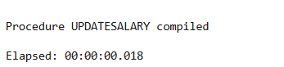

**Scenario 3:** Ensure data integrity when adding a new customer.

* + **Question:** Write a stored procedure **AddNewCustomer** that inserts a new customer into the Customers table. If a customer with the same ID already exists, handle the exception by logging an error and preventing the insertion.

1. CREATE OR REPLACE PROCEDURE AddNewCustomer(p_id NUMBER, p_name VARCHAR2, p_dob DATE, p_bal NUMBER) AS
2. BEGIN
3. INSERT INTO Customers VALUES(p_id, p_name, p_dob, p_bal, SYSDATE);
4. EXCEPTION
5. WHEN DUP_VAL_ON_INDEX THEN
6. DBMS_OUTPUT.PUT_LINE('Customer ID already exists.');
7. END;
8. /

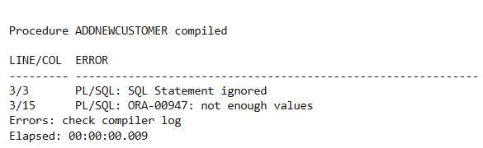

**Exercise 3: Stored Procedures**

**Scenario 1:** The bank needs to process monthly interest for all savings accounts.

* + **Question:** Write a stored procedure **ProcessMonthlyInterest** that calculates and updates the balance of all savings accounts by applying an interest rate of 1% to the current balance.

1. CREATE OR REPLACE PROCEDURE ProcessMonthlyInterest AS
2. BEGIN
3. UPDATE Accounts SET Balance = Balance + (Balance * 0.01) WHERE AccountType = 'Savings';
4. END;
5. /

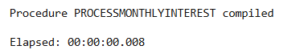

**Scenario 2:** The bank wants to implement a bonus scheme for employees based on their performance.

* + **Question:** Write a stored procedure **UpdateEmployeeBonus** that updates the salary of employees in a given department by adding a bonus percentage passed as a parameter.

1. CREATE OR REPLACE PROCEDURE UpdateEmployeeBonus(p_dept VARCHAR2, p_bonus NUMBER) AS
2. BEGIN
3. UPDATE Employees SET Salary = Salary + (Salary * p_bonus/100) WHERE Department = p_dept;
4. END;
5. /

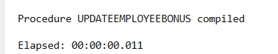

**Scenario 3:** Customers should be able to transfer funds between their accounts.

* + **Question:** Write a stored procedure **TransferFunds** that transfers a specified amount from one account to another, checking that the source account has sufficient balance before making the transfer.

1. CREATE OR REPLACE PROCEDURE TransferFunds(p_from NUMBER, p_to NUMBER, p_amt NUMBER) AS
2. v_balance NUMBER;
3. BEGIN
4. SELECT Balance INTO v_balance FROM Accounts WHERE AccountID = p_from;
5. IF v_balance >= p_amt THEN
6. UPDATE Accounts SET Balance = Balance - p_amt WHERE AccountID = p_from;
7. UPDATE Accounts SET Balance = Balance + p_amt WHERE AccountID = p_to;
8. ELSE
9. RAISE_APPLICATION_ERROR(-20002, 'Insufficient funds');
10. END IF;
11. END;
12. /

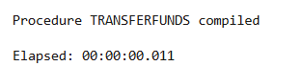

**Exercise 4: Functions**

**Scenario 1:** Calculate the age of customers for eligibility checks.

* + **Question:** Write a function CalculateAge that takes a customer's date of birth as input and returns their age in years.

1. CREATE OR REPLACE FUNCTION CalculateAge(p_dob DATE) RETURN NUMBER IS
2. BEGIN
3. RETURN TRUNC(MONTHS_BETWEEN(SYSDATE, p_dob)/12);
4. END;
5. /

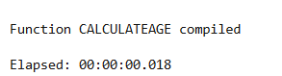

**Scenario 2:** The bank needs to compute the monthly installment for a loan.

* + **Question:** Write a function **CalculateMonthlyInstallment** that takes the loan amount, interest rate, and loan duration in years as input and returns the monthly installment amount.

1. CREATE OR REPLACE FUNCTION CalculateMonthlyInstallment(p_amount NUMBER, p_rate NUMBER, p_years NUMBER)
2. RETURN NUMBER IS
3. v_monthly_rate NUMBER := p_rate / 12 / 100;
4. v_months NUMBER := p_years * 12;
5. BEGIN
6. RETURN (p_amount * v_monthly_rate) / (1 - POWER(1 + v_monthly_rate, -v_months));
7. END;
8. /

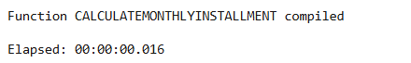

**Scenario 3:** Check if a customer has sufficient balance before making a transaction.

* + **Question:** Write a function **HasSufficientBalance** that takes an account ID and an amount as input and returns a boolean indicating whether the account has at least the specified amount.

1. CREATE OR REPLACE FUNCTION HasSufficientBalance(p_accid NUMBER, p_amt NUMBER)
2. RETURN BOOLEAN IS
3. v_balance NUMBER;
4. BEGIN
5. SELECT Balance INTO v_balance FROM Accounts WHERE AccountID = p_accid;
6. RETURN v_balance >= p_amt;
7. END;
8. /

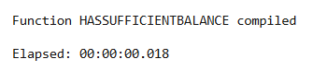

**Exercise 5: Triggers**

**Scenario 1:** Automatically update the last modified date when a customer's record is updated.

* + **Question:** Write a trigger **UpdateCustomerLastModified** that updates the LastModified column of the Customers table to the current date whenever a customer's record is updated.

1. CREATE OR REPLACE TRIGGER UpdateCustomerLastModified
2. BEFORE UPDATE ON Customers
3. FOR EACH ROW
4. BEGIN
5. :NEW.LastModified := SYSDATE;
6. END;
7. /

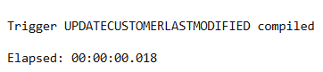

**Scenario 2:** Maintain an audit log for all transactions.

* + **Question:** Write a trigger **LogTransaction** that inserts a record into an AuditLog table whenever a transaction is inserted into the Transactions table.

1. CREATE TABLE AuditLog (
2. LogID NUMBER GENERATED BY DEFAULT AS IDENTITY PRIMARY KEY,
3. AccountID NUMBER,
4. TransactionDate DATE,
5. Amount NUMBER,
6. TransactionType VARCHAR2(10)
7. );
8. CREATE OR REPLACE TRIGGER LogTransaction
9. AFTER INSERT ON Transactions
10. FOR EACH ROW
11. BEGIN
12. INSERT INTO AuditLog(AccountID, TransactionDate, Amount, TransactionType)
13. VALUES(:NEW.AccountID, :NEW.TransactionDate, :NEW.Amount, :NEW.TransactionType);
14. END;
15. /

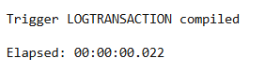

**Scenario 3:** Enforce business rules on deposits and withdrawals.

* + **Question:** Write a trigger **CheckTransactionRules** that ensures withdrawals do not exceed the balance and deposits are positive before inserting a record into the Transactions table.

1. CREATE OR REPLACE TRIGGER CheckTransactionRules
2. BEFORE INSERT ON Transactions
3. FOR EACH ROW
4. DECLARE
5. v_balance NUMBER;
6. BEGIN
7. SELECT Balance INTO v_balance FROM Accounts WHERE AccountID = :NEW.AccountID;
8. IF :NEW.TransactionType = 'Withdrawal' AND :NEW.Amount > v_balance THEN
9. RAISE_APPLICATION_ERROR(-20003, 'Insufficient funds');
10. ELSIF :NEW.TransactionType = 'Deposit' AND :NEW.Amount <= 0 THEN
11. RAISE_APPLICATION_ERROR(-20004, 'Deposit must be positive');
12. END IF;
13. END;
14. /

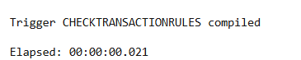

**Exercise 6: Cursors**

**Scenario 1:** Generate monthly statements for all customers.

* + **Question:** Write a PL/SQL block using an explicit cursor **GenerateMonthlyStatements** that retrieves all transactions for the current month and prints a statement for each customer.

1. DECLARE
2. CURSOR c_txn IS
3. SELECT * FROM Transactions WHERE EXTRACT(MONTH FROM TransactionDate) = EXTRACT(MONTH FROM SYSDATE);
4. BEGIN
5. FOR rec IN c_txn LOOP
6. DBMS_OUTPUT.PUT_LINE('Customer Transaction ID: ' || rec.TransactionID || ' Amount: ' || rec.Amount);
7. END LOOP;
8. END;
9. /

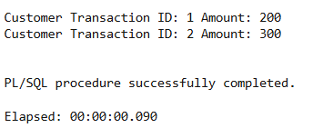

**Scenario 2:** Apply annual fee to all accounts.

* + **Question:** Write a PL/SQL block using an explicit cursor **ApplyAnnualFee** that deducts an annual maintenance fee from the balance of all accounts.

1. DECLARE
2. CURSOR c_acct IS SELECT AccountID FROM Accounts;
3. BEGIN
4. FOR rec IN c_acct LOOP
5. UPDATE Accounts SET Balance = Balance - 100 WHERE AccountID = rec.AccountID;
6. END LOOP;
7. END;
8. /



**Scenario 3:** Update the interest rate for all loans based on a new policy.

* + **Question:** Write a PL/SQL block using an explicit cursor **UpdateLoanInterestRates** that fetches all loans and updates their interest rates based on the new policy.

1. DECLARE
2. CURSOR c_loan IS SELECT LoanID FROM Loans;
3. BEGIN
4. FOR rec IN c_loan LOOP
5. UPDATE Loans SET InterestRate = InterestRate + 0.5 WHERE LoanID = rec.LoanID;
6. END LOOP;
7. END;
8. /



**Exercise 7: Packages**

**Scenario 1:** Group all customer-related procedures and functions into a package.

* + **Question:** Create a package **CustomerManagement** with procedures for adding a new customer, updating customer details, and a function to get customer balance.

1. CREATE OR REPLACE PACKAGE CustomerManagement AS
2. PROCEDURE AddCustomer(p_id NUMBER, p_name VARCHAR2, p_dob DATE, p_bal NUMBER);
3. PROCEDURE UpdateCustomer(p_id NUMBER, p_name VARCHAR2);
4. FUNCTION GetCustomerBalance(p_id NUMBER) RETURN NUMBER;
5. END;
6. /
7. CREATE OR REPLACE PACKAGE BODY CustomerManagement AS
8. PROCEDURE AddCustomer(p_id NUMBER, p_name VARCHAR2, p_dob DATE, p_bal NUMBER) IS
9. BEGIN
10. INSERT INTO Customers VALUES(p_id, p_name, p_dob, p_bal, SYSDATE);
11. END;
12. PROCEDURE UpdateCustomer(p_id NUMBER, p_name VARCHAR2) IS
13. BEGIN
14. UPDATE Customers SET Name = p_name WHERE CustomerID = p_id;
15. END;
16. FUNCTION GetCustomerBalance(p_id NUMBER) RETURN NUMBER IS
17. v_bal NUMBER;
18. BEGIN
19. SELECT Balance INTO v_bal FROM Customers WHERE CustomerID = p_id;
20. RETURN v_bal;
21. END;
22. END;
23. /

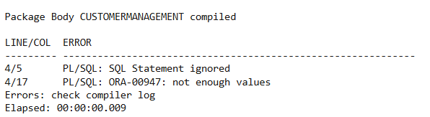

**Scenario 2:** Create a package to manage employee data.

* + **Question:** Write a package **EmployeeManagement** with procedures to hire new employees, update employee details, and a function to calculate annual salary.

1. CREATE OR REPLACE PACKAGE EmployeeManagement AS
2. PROCEDURE HireEmployee(p_id NUMBER, p_name VARCHAR2, p_pos VARCHAR2, p_sal NUMBER, p_dept VARCHAR2);
3. PROCEDURE UpdateEmployee(p_id NUMBER, p_sal NUMBER);
4. FUNCTION GetAnnualSalary(p_id NUMBER) RETURN NUMBER;
5. END;
6. /
7. CREATE OR REPLACE PACKAGE BODY EmployeeManagement AS
8. PROCEDURE HireEmployee(p_id NUMBER, p_name VARCHAR2, p_pos VARCHAR2, p_sal NUMBER, p_dept VARCHAR2) IS
9. BEGIN
10. INSERT INTO Employees VALUES(p_id, p_name, p_pos, p_sal, p_dept, SYSDATE);
11. END;
12. PROCEDURE UpdateEmployee(p_id NUMBER, p_sal NUMBER) IS
13. BEGIN
14. UPDATE Employees SET Salary = p_sal WHERE EmployeeID = p_id;
15. END;
16. FUNCTION GetAnnualSalary(p_id NUMBER) RETURN NUMBER IS
17. v_sal NUMBER;
18. BEGIN
19. SELECT Salary INTO v_sal FROM Employees WHERE EmployeeID = p_id;
20. RETURN v_sal * 12;
21. END;
22. END;
23. /

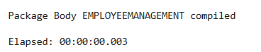

**Scenario 3:** Group all account-related operations into a package.

* + **Question:** Create a package **AccountOperations** with procedures for opening a new account, closing an account, and a function to get the total balance of a customer across all accounts.

1. CREATE OR REPLACE PACKAGE AccountOperations AS
2. PROCEDURE OpenAccount(p_id NUMBER, p_custid NUMBER, p_type VARCHAR2, p_bal NUMBER);
3. PROCEDURE CloseAccount(p_id NUMBER);
4. FUNCTION GetTotalBalance(p_custid NUMBER) RETURN NUMBER;
5. END;
6. /
7. CREATE OR REPLACE PACKAGE BODY AccountOperations AS
8. PROCEDURE OpenAccount(p_id NUMBER, p_custid NUMBER, p_type VARCHAR2, p_bal NUMBER) IS
9. BEGIN
10. INSERT INTO Accounts VALUES(p_id, p_custid, p_type, p_bal, SYSDATE);
11. END;
12. PROCEDURE CloseAccount(p_id NUMBER) IS
13. BEGIN
14. DELETE FROM Accounts WHERE AccountID = p_id;
15. END;
16. FUNCTION GetTotalBalance(p_custid NUMBER) RETURN NUMBER IS
17. v_total NUMBER;
18. BEGIN
19. SELECT SUM(Balance) INTO v_total FROM Accounts WHERE CustomerID = p_custid;
20. RETURN v_total;
21. END;
22. END;
23. /

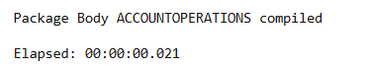

**Schema to be Created**

*CREATE TABLE Customers (*

*CustomerID NUMBER PRIMARY KEY,*

*Name VARCHAR2(100),*

*DOB DATE,*

*Balance NUMBER,*

*LastModified DATE*

*);*

*CREATE TABLE Accounts (*

*AccountID NUMBER PRIMARY KEY,*

*CustomerID NUMBER,*

*AccountType VARCHAR2(20),*

*Balance NUMBER,*

*LastModified DATE,*

*FOREIGN KEY (CustomerID) REFERENCES Customers(CustomerID)*

*);*

*CREATE TABLE Transactions (*

*TransactionID NUMBER PRIMARY KEY,*

*AccountID NUMBER,*

*TransactionDate DATE,*

*Amount NUMBER,*

*TransactionType VARCHAR2(10),*

*FOREIGN KEY (AccountID) REFERENCES Accounts(AccountID)*

*);*

*CREATE TABLE Loans (*

*LoanID NUMBER PRIMARY KEY,*

*CustomerID NUMBER,*

*LoanAmount NUMBER,*

*InterestRate NUMBER,*

*StartDate DATE,*

*EndDate DATE,*

*FOREIGN KEY (CustomerID) REFERENCES Customers(CustomerID)*

*);*

*CREATE TABLE Employees (*

*EmployeeID NUMBER PRIMARY KEY,*

*Name VARCHAR2(100),*

*Position VARCHAR2(50),*

*Salary NUMBER,*

*Department VARCHAR2(50),*

*HireDate DATE*

*);*

*INSERT INTO Customers VALUES (1, 'John Doe', TO_DATE('1985-05-15', 'YYYY-MM-DD'), 1000, SYSDATE);*

*INSERT INTO Customers VALUES (2, 'Jane Smith', TO_DATE('1950-07-20', 'YYYY-MM-DD'), 15000, SYSDATE);*

*INSERT INTO Accounts VALUES (1, 1, 'Savings', 1000, SYSDATE);*

*INSERT INTO Accounts VALUES (2, 2, 'Checking', 1500, SYSDATE);*

*INSERT INTO Transactions VALUES (1, 1, SYSDATE, 200, 'Deposit');*

*INSERT INTO Transactions VALUES (2, 2, SYSDATE, 300, 'Withdrawal');*

*INSERT INTO Loans VALUES (1, 2, 5000, 5, SYSDATE, ADD_MONTHS(SYSDATE, 1));*

*INSERT INTO Employees VALUES (1, 'Alice Johnson', 'Manager', 70000, 'HR', TO_DATE('2015-06-15', 'YYYY-MM-DD'));*

*INSERT INTO Employees VALUES (2, 'Bob Brown', 'Developer', 60000, 'IT', TO_DATE('2017-03-20', 'YYYY-MM-DD'));*

**Example Scripts for Sample Data Insertion**

*INSERT INTO Customers (CustomerID, Name, DOB, Balance, LastModified)*

*VALUES (1, 'John Doe', TO_DATE('1985-05-15', 'YYYY-MM-DD'), 1000, SYSDATE);*

*INSERT INTO Customers (CustomerID, Name, DOB, Balance, LastModified)*

*VALUES (2, 'Jane Smith', TO_DATE('1990-07-20', 'YYYY-MM-DD'), 1500, SYSDATE);*

*INSERT INTO Accounts (AccountID, CustomerID, AccountType, Balance, LastModified)*

*VALUES (1, 1, 'Savings', 1000, SYSDATE);*

*INSERT INTO Accounts (AccountID, CustomerID, AccountType, Balance, LastModified)*

*VALUES (2, 2, 'Checking', 1500, SYSDATE);*

*INSERT INTO Transactions (TransactionID, AccountID, TransactionDate, Amount, TransactionType)*

*VALUES (1, 1, SYSDATE, 200, 'Deposit');*

*INSERT INTO Transactions (TransactionID, AccountID, TransactionDate, Amount, TransactionType)*

*VALUES (2, 2, SYSDATE, 300, 'Withdrawal');*

*INSERT INTO Loans (LoanID, CustomerID, LoanAmount, InterestRate, StartDate, EndDate)*

*VALUES (1, 1, 5000, 5, SYSDATE, ADD_MONTHS(SYSDATE, 60));*

*INSERT INTO Employees (EmployeeID, Name, Position, Salary, Department, HireDate)*

*VALUES (1, 'Alice Johnson', 'Manager', 70000, 'HR', TO_DATE('2015-06-15', 'YYYY-MM-DD'));*

*INSERT INTO Employees (EmployeeID, Name, Position, Salary, Department, HireDate)*

*VALUES (2, 'Bob Brown', 'Developer', 60000, 'IT', TO_DATE('2017-03-20', 'YYYY-MM-DD'));*